Architecture and Context Diagram
Public Procurement Document-Completeness Agent
Group-H (Evening), Makerere University

1. Introduction
This document proposes an initial system context and a first-pass component architecture for the use case defined in Task 1: Selection and Definition of the Project Use Case. It follows the same evidentiary rules as Task 1 verified fact, project decision, proposal, assumption, and information gap are kept distinct throughout.
No architecture-specific decisions (technology stack, hosting, specific LLM provider, confidence thresholds) have yet been confirmed by the team or supervisor. Everything presented as a diagram element or component below is therefore a proposal derived from the confirmed use case, actors, flows, and safety boundary in Task 1, the Project Charter, and the User Stories & Acceptance Criteria not a committed design. Open points are consolidated in the Information Gap Register (Section 9).

2. System Context Diagram
The diagram below shows the system as a single box, its two human actor types, and its external dependencies. This is a system-context view in the style of the C4 model's Level 1 diagram (Brown, n.d.), used here only as a documentation convention, not as a specific tool or technology decision.
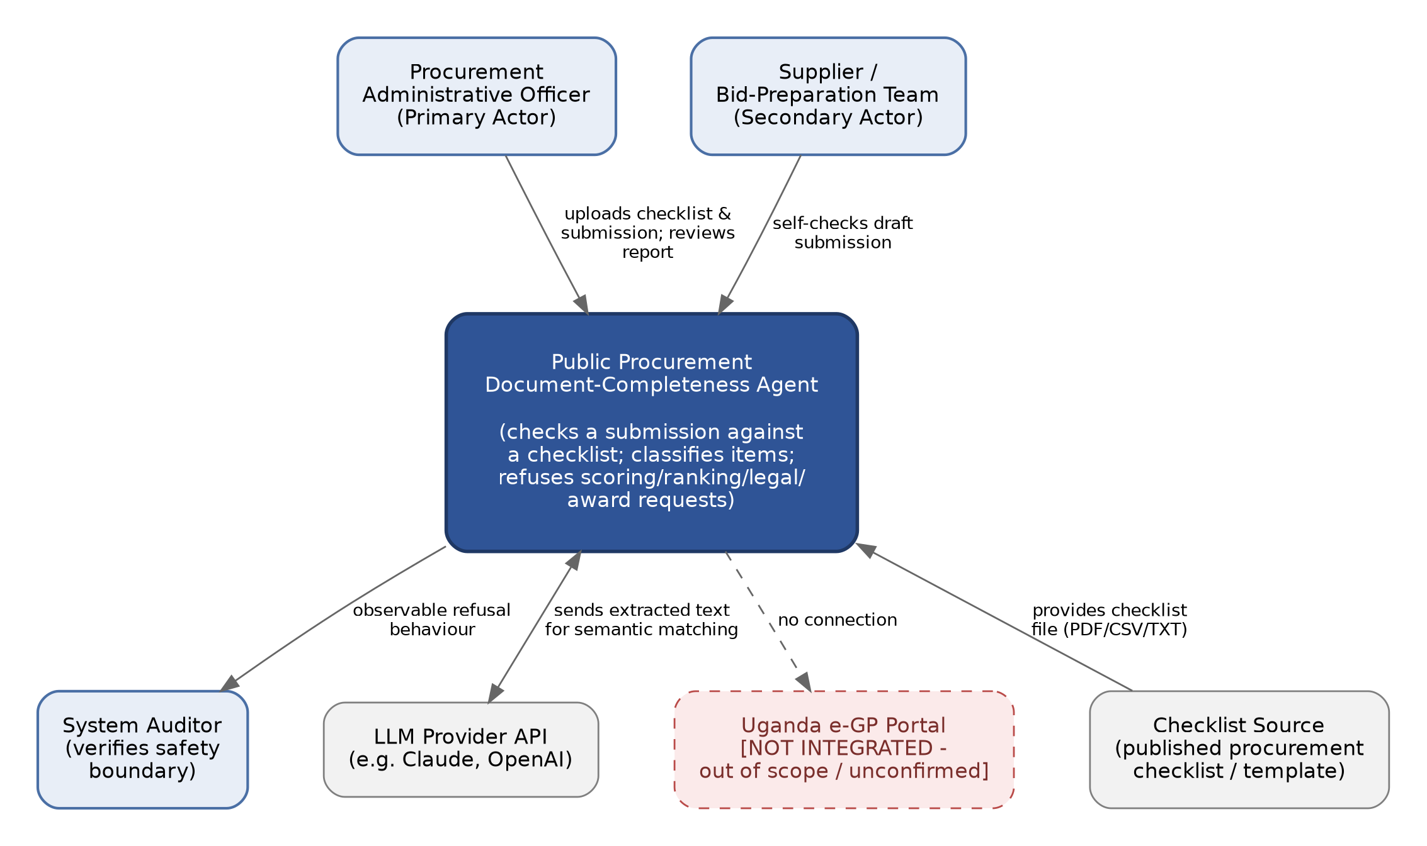
Figure 1. System context: actors, the proposed system, and external dependencies.
The LLM Provider API is shown as an external system because semantic matching (interpreting a checklist requirement and locating equivalent wording) is the core AI capability described in the Charter's “AI Value” section, and the team's stated constraint is to use an LLM agent via API (Project Charter, 2026).
The Uganda e-GP portal is explicitly shown as not integrated. Neither the Charter nor the User Stories mention e-GP, and the team has not confirmed it is in scope, so it is drawn but marked out of the current boundary rather than omitted silently (IG-05).

3. Component Architecture Diagram
The diagram below decomposes the system into first-pass components. Component boundaries follow the main flow already confirmed in Task 1 (upload checklist → edit items → upload submission → match → classify → human review → export), plus a dedicated component for the safety-boundary refusals required by User Stories AC6–AC9.
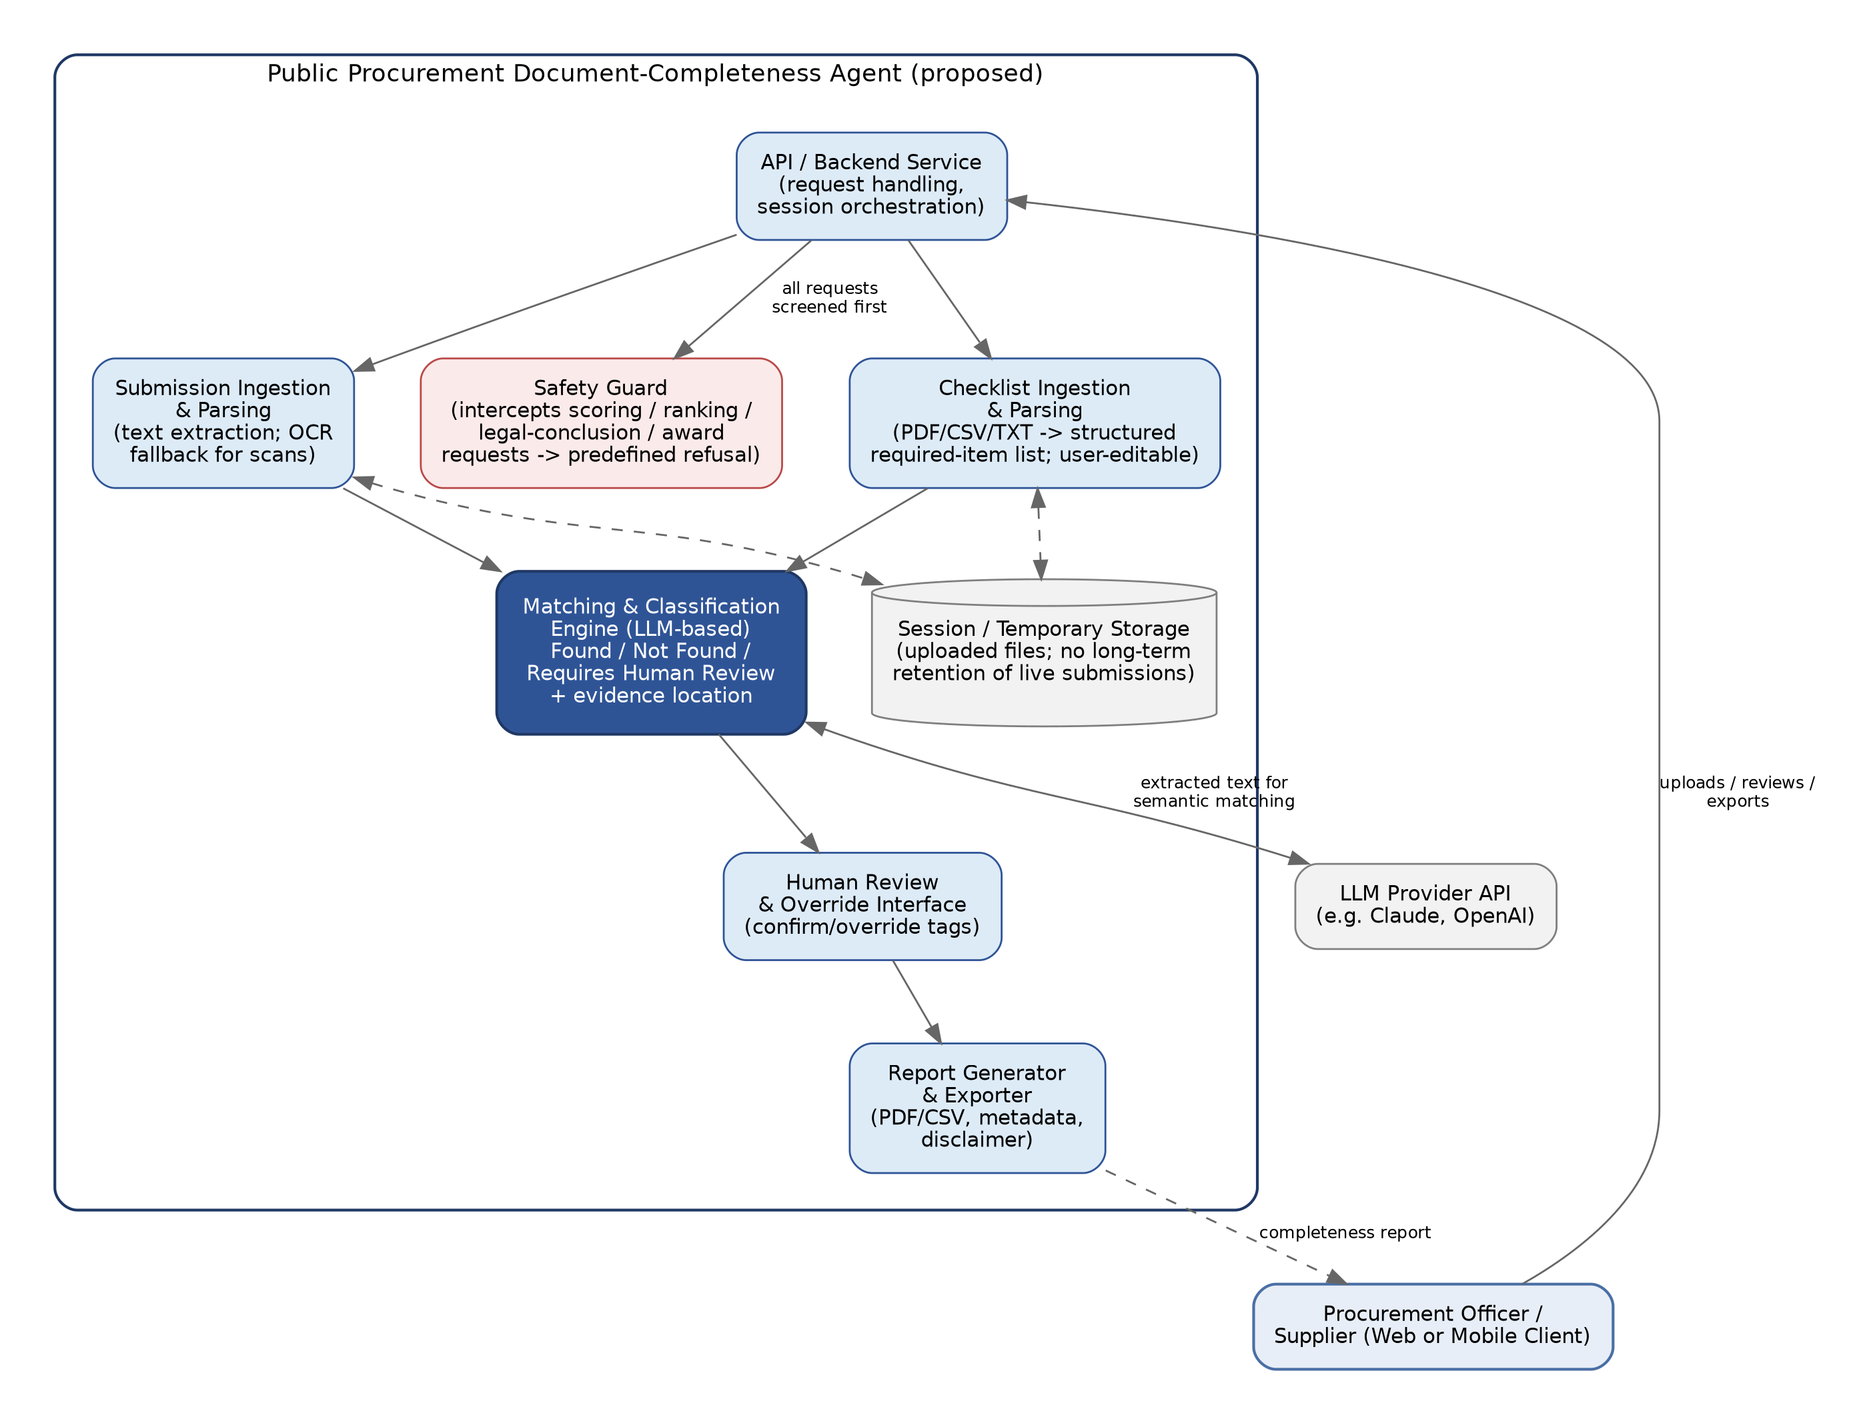
Figure 2. Proposed component architecture (initial, pre-technology-selection).

4. Component Descriptions
API / Backend Service: receives client requests, orchestrates the other components, manages the session for a single in-progress completeness check.
Safety Guard: screens incoming requests before they reach the matching engine; recognises requests for scoring, ranking, legal conclusions, or award recommendations and returns a predefined refusal instead of processing them (User Stories, AC6–AC9). Positioned as a gate on the API layer so that no downstream component needs to re-implement this check.
Checklist Ingestion & Parsing: accepts PDF/CSV/TXT checklist files, extracts a structured list of required items, and exposes them for manual user editing before a check is run (User Stories, AC1).
Submission Ingestion & Parsing: accepts the tender submission, extracts text, and falls back to OCR for scanned/image-based pages (Project Charter, 2026, document-quality constraint).
Matching & Classification Engine: the LLM-backed component that interprets each checklist requirement, searches the parsed submission for satisfying text, and classifies each item as Found, Not Found, or Requires Human Review, recording a page/section/snippet as evidence for Found items (User Stories, AC3, AC4, AC10).
Human Review & Override Interface: presents “Requires Human Review” items to the user and lets them confirm the tag as Found or Missing (User Stories, AC10).
Report Generator & Exporter: compiles the final classification list, evidence locations, and submission metadata into an exportable PDF or CSV, with the required completeness-check-only disclaimer (User Stories, AC5, AC8).
Session/Temporary Storage: holds uploaded files and intermediate parsing results for the duration of a check. Given the Charter's data-access constraint (synthetic/anonymised data, avoiding exposure of confidential live tenders), this is proposed as transient storage rather than a long-term repository; retention policy is an open point (IG-12, IG-13).

5. Data Flow
1. User uploads a checklist → Checklist Ingestion & Parsing extracts required items → user edits the list.
2. User uploads a submission → Submission Ingestion & Parsing extracts text (OCR if needed).
3. API forwards both parsed sets to the Matching & Classification Engine, which calls the LLM Provider API to interpret and locate each requirement.
4. The engine returns a classified list with evidence locations; low-confidence items are routed to the Human Review & Override Interface.
5. The user confirms/overrides review items → Report Generator & Exporter compiles the final report → user downloads it.
At every stage, the Safety Guard sits in front of the API layer: any request that asks the system to score, rank, compare submissions, draw a legal conclusion, or recommend an award is intercepted and refused before reaching the matching engine (User Stories, AC6–AC9).

6. Technology Proposals (Not Yet Confirmed)
The following are candidate technologies suggested to fit the confirmed constraints (web/mobile focus; LLM-agent-via-API constraint; PDF/CSV/TXT input; OCR fallback). None have been confirmed by the team; they are offered as a starting point for discussion, not as decisions.
Client: a web front end (e.g. React) as the primary interface, given the reviewer-desk nature of the primary use case, with the team's general mobile focus addressed separately once IG-08 is resolved.
Backend: a Python web framework (e.g. FastAPI or Django REST Framework), chosen for straightforward integration with both document-parsing libraries and LLM provider SDKs.
Checklist/submission parsing: a PDF text-extraction library (e.g. pdfplumber or PyMuPDF) plus a CSV/TXT parser; an OCR engine (e.g. Tesseract) for scanned pages (IG-10).
Matching & Classification: an LLM accessed via API (e.g. Claude or an OpenAI model, per the team's stated constraint), called with the parsed checklist item and relevant submission text to determine a match and confidence level (IG-09, IG-11).
Report export: a PDF-generation library and a CSV writer for the two required export formats (User Stories, AC5).

7. Design Rationale
The component split follows directly from the confirmed main flow and acceptance criteria rather than from a generic template: a dedicated Safety Guard exists because four of the ten confirmed acceptance criteria (AC6–AC9) are safety-boundary refusals, not completeness-checking behaviour, and separating this concern means the refusal logic is enforced once, centrally, rather than scattered across components. The three-way classification (Found / Not Found / Requires Human Review) is carried into the Matching & Classification Engine as a first-class output rather than a binary match/no-match, because AC10 requires a distinct review-and-override path for low-confidence items. Session storage is deliberately scoped as transient, consistent with the Charter's constraint that confidential live tender data should not be exposed during development and testing.

8. Assumptions and Constraints Carried Into This Architecture
Data access: development and testing use public checklists/templates plus synthetic or anonymised submissions, not confidential live tenders (Project Charter, 2026).
Document quality: scanned pages, images, and inconsistent formatting can reduce extraction accuracy, which is why an OCR fallback and a “Requires Human Review” path exist rather than a single deterministic parser (Project Charter, 2026).
Language ambiguity: a submission may satisfy a requirement without matching its exact wording, which is why matching is proposed as LLM-based semantic interpretation rather than keyword search (Project Charter, 2026).
Human oversight: a human reviewer remains in control of the final interpretation of every finding; the architecture reflects this by keeping the Human Review & Override Interface as a mandatory step before export, not an optional one (Project Charter, 2026).

9. References
Brown, S. (n.d.). The C4 model for visualising software architecture. https://c4model.com/
Group-H (BSE 4100). (2026). Public procurement document completeness agent: Project charter [Unpublished project document, Makerere University].
Group-H (BSE 4100). (2026). Public procurement agent: User stories & acceptance criteria [Unpublished project document, Makerere University].
Katongole, J. (2026). Task 1: Selection and definition of the project use case — Public procurement document-completeness agent [Unpublished project document, Makerere University].

